

Final Year Project Proposal

Project Title:
Smart Shopping System

Submitted by:
Muhammad Aashir Raza (38592)
Mohd Essa (37826)
Laiba Aftab (41041)
Mahnoor Moosa Raza (40282)

Supervisor:
Sophia Ajaz

Coordinator:
Dr. Mansoor Ebrahim
List of Abbreviations and Acronyms

QR CODE (Quick Response)
RFID (radio frequency identification)

Table of Contents

Description Page #

Section – 1 1
1.1 Project Identification 1
Section – 2 5
2.1 Background 5
2.2 Outcomes and Benefits 6
2.3 Objectives 6
2.4 Research Approach 7
2.5 Risk Analysis 8
Section – 3 9
3.1 Resources & Other Requirements 9
Annexure–A: Project Schedule / Milestone Chart 11
Annexure–B: Proposed Budget 12
Annexure–C: Business Canvas Model 13
Bibliography 14

Final Year Project Proposal

Section – 1

1.1 Project Identification
Project Title:
Smart Inventory System

Group Leader (GL):
1. | Name: | Muhammad Aashir Raza
 | Reg #: | 38592
 | CGPA: | 2.4
 | Mobile # : | 03340379123 | Email: |  |  | Aashirraza12@gmail.com
 | Signature:
Group Members (GM’s):
2. | Name: | Laiba Aftab
 | Reg #: | 41041
 | CGPA: | 3.35
 | Mobile # : | 03022818092 |  | Email: |  |  | laibaaftabdar@gmail.com
 | Signature:
3. | Name: | Mahnoor Moosa Raza
 | Reg #: | 40282
 | CGPA: | 2.5
 | Mobile # : | 03333777526 |  | Email: |  |  | Mahnoorraza477@gmail.com
 | Signature:
4 | Name : | Mohd Essa
 | Reg #: | 37826
 | CGPA : | 2.59
 | Mobile #: | 03129813926
 | Email : | Essa.nagari2@gmail.com
 | Signature:

What technology is core to your product? (Please mark ☑ where applicable)
[ ] 3D/4D Printing |  | [ ] Augmented Reality / Virtual Reality
[ ] Big Data, Artificial Intelligence |  | [ ] Blockchain
[ ] Cloud |  | [ ] Neurotech
[ ] Robotics |  | [ ] Shared economy
[ ] The Internet of Things |  | [ ] Wearables, Implantables
- Others (specify): | Mob Application

What is the target market(s) for the products? (Please mark ☑ where applicable)
[ ] Automotive, aviation, marine |  | [ ] Business, marketing, finance
[ ] Defence, security, safety |  | [ ] Education and training
[ ] Environment, water management |  | [ ] Entertainment, tourism, sport/recreation
[ ] Food, livestock, agribusiness |  | [ ] Healthcare
[ ] Infrastructure, housing & transport |  | [ ] Mining equipment technology & services
[ ] Oil, gas, energy |  | [ ] Textiles, clothing, footwear
[ ] Others (specify): | Shopping mall, Marketing

Other Organizations Involved in the Project: (Please identify all affiliated organizations collaborating in the project, and describe their role/contribution to the project.)
Academic Organizations:
# | Organization Name |  |  | Role / Contribution
 | Iqra University |  |  | Guider , Lecturer
Industrial Organizations:
# | Organization Name |  | Role / Contribution
 | Imtiaz Super Market |  | Stakeholder
Funding Organizations:
# | Organization Name |  |  | Role / Contribution
Key Words: (Please provide a maximum of 5 key words that describe the project)
Smart Shopping system, Electronic barcode system, Less Manpower, Automated shopping system, Image processing, Shopping behavior

Research and Development Theme: (please identify the Research Theme.)
We have researched that, on many areas the process of smart shopping system faces a problem that is for scanning multiple products at a time. We are finding ways to overcome the issue.
Our development is based on desktop which will be made on C# and the technology which we will be using is mobile application and the language will be kotlin. The information of the products being bought will be saved in a database.

Project Status: (Please mark ☑)
- New
[ ] Modification to previous Project
[ ] Extension of existing project

Project Duration: |  | 12 Months
Proposed Budget: |  | ----------
The Problem:
- (Please describe the problem / opportunity / gap / need that you want to address/solve. Maximum 300 words.)
Security Issue about multiple product. Supermarkets are not completely equipped with systems that can help in reducing congestion.
- Security is a major issue in a crowded environment as customer belongings, credit and debit card information are sometimes stolen. Errors are usually inevitable when in putting product into the electronic Point of Sales when demand is high (crowded) which often lead to loss of sales for the supermarket when using current systems.
- The electronic Point of Sales in use is usually expensive and requires regular updates from the manufacturer, which requires the use of the internet which causing cost as well. However, the use of electronic Point of Sales adopted by most supermarkets around the world are efficient yet limited in some ways. It lowers margin for human error, monitors staff activity, and the integrated systems help in getting the job done faster. But this system is susceptible to human error when demands from customer increase, and most times are also quite expensive to buy and maintain. If this system is used and no improvement is made to the system, congestion, security breaches, errors made by humans as a result of high demand as well as the high cost of acquiring the system would eventually become a huge disadvantage to the seller.

Following are some of the Current State of the Art (well-known -identify the best known if possible) existing solutions to this problem. Their known strengths and weaknesses are also provided.
(Maximum 200 words.)
We noticed some of their strengths and weaknesses. Our BGSC capitalizes on some of these weaknesses. Some of the strengths of the reviewed systems include; designs that enable easy access to products, presence of cookies to keep track of users shopping experiences and store them at the server end, platforms for advertisement of latest products by companies, a physical shop where complaints can be made, and an additional feature of collection points, wide range of payment options such as voucher codes, credit cards and insurance. Some of the weaknesses observed in the systems include; the use of credit cards for purchase which could be hacked i.e. credit card’s susceptibility to hackers, unavailability of collection points, extra charges incurred on delivery, goods damaged cannot be returned or refunded, services limited to a particular country (i.e. for example Argos services are only limited to the UK and Ireland only)

Our solution will address the following weaknesses of above-mentioned solutions.
(Maximum 200 words.)
The BGSC would implement the strengths observed in these systems as well as improve upon the weaknesses noticed as follows:

- It would generate a barcode which will reduce or eliminate the possibilities of errors occurring when purchasing at the counter and save time because customers would come to a collection point to pick their goods in-stead of waiting on a queue to make payment.

- It would make use of vouchers as a mode of payment, which would restrain and check some of the security complications associated with credit cards such as their susceptibility to hacking as well as social engineering.

- It would work with collection points. Thus reducing congestion

- The system would support the return of goods damaged at the point of package and also have a refund policy for customers who at the point of collection may not be satisfied with the product they initially purchased.

- The cost of goods would also be reduced, because only the system requires a very minimal cost to implement compared to electronic Point of Sale being used in supermarkets which require constant update and are expensive to purchase.

We will use the following techniques to achieve improvements mentioned above.
(Maximum 200 words.)
In order to solve these problems, the BGSCS, would reduce congestion by implementing a collection point where goods ordered online can be collected by customers, the use of credit and debit cards would be substituted with the use of vouchers and cash payments, mistakes made by the cashier will be minimized with the use of the barcodes generated when an order is made by the customer online. The cost of purchasing more electronic Point of Sales systems would be reduced as the use of the BGSCS which is cheap and requires little maintenance by the administrator will consequently increase profit.
In order to design and implement this system the following objectives must be attained:
- Review existing systems and identify their various limitations.
- Design a barcode generating shopping cart that that is simple and scalable as new services can be easily implemented and added to the system.
- Design an administrator system web application which would be installed on the Point of Sales machines that would manage orders and payments of the customers.
- Design and implement a robust database that would eliminate redundancy, improve data integrity, and enhance concurrent operations. It would also access control measures, this would enhance the security of the application and the database

Synopsis:
(A brief description of the idea, in non-technical language, explaining product benefit, target market, basic technology, commercial partners, investors, and potential customers. Maximum 200 words.)
Supermarkets are not completely equipped with systems that reduce congestion, secure customer belongings, prevent card information theft, and reduce error when input-ting product details into the electronic Point of Sales device when demand increases which often leads to loss of sales. Human error margin is lowered under ideal circumstances, staff activity is monitored, and integrated systems execute job faster. In order to yield better results, the-Barcode Generating Shopping Cart System (BGSCS), aims at reducing congestion through a collection point; once goods are ordered online, vouchers and cash payments are used to prevent card information theft, barcodes are employed also in order to minimize mistakes made by cashiers and the cost of purchasing more current systems is saved by using BGSCS (which is cheap and requires little maintenance) thus profit is maximized. The Agile methodology is used, which adopts a linear model, this ensures that execution of design procedures remain simple and straightforward. Our main idea will only be applied on the products in which RFID tag will be attached. In our application for each and every product there will be a database. We can easily scan the product and keep it in the bucket. After shopping our QR will be generated and scanned on different hubs. Direct bill will be paid or else cash at the bill counter and the bill will also be scanned. By the process our system gets more secured and becomes an easy access to shop anytime.

Section -2

2.1 Background

Scope of the Project: In this modern era of technology, shopping is done in various ways be it online or manually. So we are developing a system that can be done easily through RFID(Radio Frequency Identification) products which will be scanned through bar code scanners.
The main scope of our project is to deal with the daily problem people face while shopping. The desktop will be made on C# and the technology which we will be using is mobile application and language will be java or kotlin.
Our main focus would be on making it easy to use for the customers, make it secure with less cost. So, we are making this system for Imtiaz supermarket or maybe any other store so that customers could shop easily.
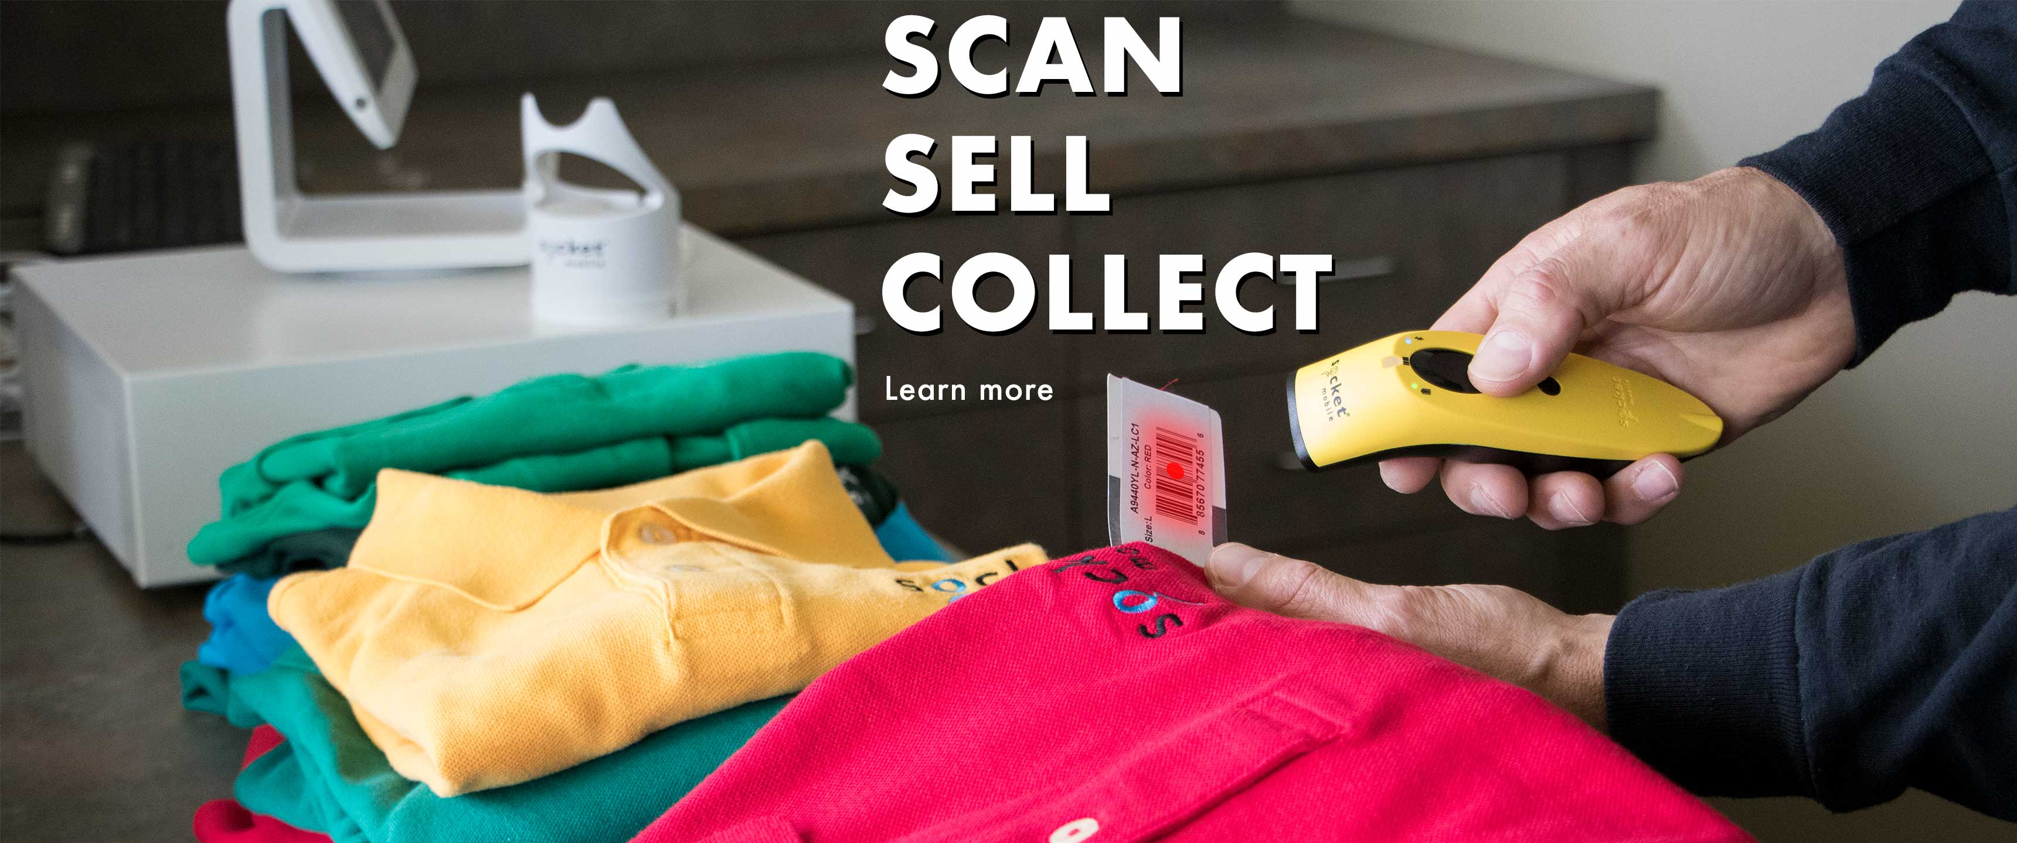

Literature Review:
This section focuses on the analysis of some works that have been found to be closely related to shopping cart and barcode technology. This provides a means of performing a comparative analysis between the related works and our system.
- Amazon Market
Background:
This is a UK and US based online shop. It has a very classic homepage which has two purposes; product searches and online purchasing. Its navigation section located in the upper-left side of the page makes it easier for users to quickly find and purchase product and it allows sellers to quickly process online purchases.
System: It has features such as cookies which are used to keep users logged-in, and monitor customer’s shopping habits. This feature customizes the user’s experience based on prior searches, page views, wish-list additions, written reviews and, ultimately, purchases. Amazon uses drop shopping product delivery method.
Problem: With all its good features, has some weakness. Goods delivered may be damaged and no refund policy is available to the customer. There is the possibility of customers’ bank details being stolen online even though it is believed to be a secure website.
- Konga Market
Background: This is a Nigerian online shop. Like Amazon, Konga has two main purposes which are the ability to search for products and make online purchases.
System: With the structure of Konga’s home page, the purposes mentioned are achieved due to the fact that users are able to quickly find and make product purchases and it also allows the seller to rapidly process purchases made online. It has a feature that shows the most searched for goods on the website within a particular time frame, which gives the consumer an idea of what is trend-ing and what to buy to stay in touch with fashion and society.
Problem It also makes use of cookies, just like Amazon shop, it has no refund policy that favours the customer, and customers’ credit and debit card details can be stolen online.
- Barcode Technology Effect on Medication Ad-ministration (Barcode-eMAR)
Background: This is a major application of barcode used now to save lives and prevent unnecessary problems in the hospital. The Barcode eMAR technology integrates several technologies into the workflow of the nursing staff to make sure the right medication is administered at the correct dose, correct time and to the correct patient.
System: The traditional way, which involves medication orders placed by physicians are manually put in writing to the paper medication-administration record, which nurses use to determine what medications to administer and when. It creates more protection surface by making sure nurses scan barcodes on the patient’s wristband and on the medication before it is administered. If the scanned dose tallies to an approved pharmacist medication order, the patient is considered due for the dose and it is documented automatically. However, if the dose does not tally with an order that is valid, the application gives a warning.
Problem: Barcodes have been used to pre-vent medication errors. These errors are found in order transcription, medication administration and potential adverse drug events, although it does not eliminate such errors.
- Argos Market
Background: It is based in the UK and Ireland with 737 stores and 340 million website visits yearly. Argos is rated as one of the largest high street retailers in the UK.
System: Its strengths are; its user friendly design which provides easy access to products, it uses cookies to keep track of users shopping experience and stores it at the server-end, it creates a plat-form for advertisement of latest products by companies. It has a physical shop to make complaint and additional feature of collection point. It also has wide payment module: credit card, voucher codes, Argos card, Argos gift cards, Argos, credit card and insurance. Argos has some weaknesses as well.
Problem: These weakness are; it is limited to the UK and Ire-land only, unauthorized access to credit details by hackers is possible, and it uses a third party ship-ping organization which most of the time increases the cost of items purchased.
Challenges: (Please describe the challenges, specific to this research topic, currently being faced internationally. Maximum 500 words.)

The biggest challenge for us to learn the system efficient.

Independent variables in this project are as follows:
- Financial risks
- Camera issues
- Product risks
- Convenience risk
- Non-delivery risk
- Infrastructural variables
- Return policy
- Attitude
- Subjective norms
- Perceived behavioral control
- Domain specific innovativeness
Dependent variables are:
- Attitude
- Online shopping behavior

Motivation and Need: (Please describe the motivation and need for this work. Maximum 500 words)
MOTIVATION: A barcode is a machine-readable strip of data printed in parallel lines, used to represent a multitude of information. Traditionally, a barcode scanner is used by retailers to keep track of inventory and speed up data entry. Due to their heavy commercial and industrial sector usage, barcode scanning applications have been producer-centric, focusing on improving the efficiency, accuracy, and productivity of supply management. In contrast, we want to create an application that is consumer-centric. This application would function as a personal shopper, assisting the user by allowing him to add items to an online database or "wish list". With browser integration, this application could also be extended to search for product reviews or even price comparisons. The uses for a barcode reader in the marketplace are numerous and there are endless ways to tie it to the consumer to make exciting and innovative applications. For convenience, our device should also be easy to carry and use. We are not expecting a user to haul around a bulky device with limited functionality. Instead, we wanted the application to be loadable onto a small, multifunctional embedded device like a cell phone or PDA.
NEED: Due to long waiting and security issues.

  - Outcomes and Benefits

Expected Outcomes: (Provide a list of proposed project outputs including publications, databases etc.)
These are the following output we expect from the system to give us:
- It would generate a barcode which will reduce or eliminate the possibilities of errors occurring when purchasing at the counter and save time because customers would come to a collection point to pick their goods in-stead of waiting on a queue to make payment.

- It would make use of vouchers as a mode of payment, which would restrain and check some of the security complications associated with credit cards such as their susceptibility to hacking as well as social engineering.

- It would work with collection points. Thus reducing congestion

- The system would support the return of goods damaged at the point of package and also have a refund policy for customers who at the point of collection may not be satisfied with the product they initially purchased.

- The cost of goods would also be reduced, because only the system requires a very minimal cost to implement compared to electronic Point of Sale being used in supermarkets which require constant update and are expensive to purchase.

Key Benefits and Beneficiaries: (Please identify clearly the benefits and potential customers/beneficiaries of the project.)
These are some uses of this system:
- Barcodes eliminate the possibility of human error. The occurrence of errors for manually entered data is significantly higher than that of barcodes.
- A barcode scan is fast and reliable, and takes infinitely less time than entering data by hand. Using a barcode system reduces employee training time.
- Barcodes provide better data. Since one barcode can be used for inventory and pricing information, it is possible to quickly obtain data on both. Furthermore, barcodes can be customized to contain other relevant information as needed. They provide fast, reliable data for a wide variety of applications.
- Data obtained through barcodes is available rapidly. Since the information is scanned directly into the central computer, it is ready almost instantaneously. This quick turnaround ensures that time will not be wasted on data entry or retrieval.
- This shopping system is more secure, private and easy to use than any other system.

BENIFICIARIES
This system is giving benefits to many people like:
- User can easily shop and pay the bill without getting into the line and waiting.
- There will be less rush on the counter so that counter man has the chance to face less problems.
- People/customers who don’t have the capability to handle many products or to shop can easily buy and shop as many products they want.

Technology Transfer/Diffusion Approach: (Please describe how the outputs of the project will be transferred to the beneficiaries/customers. Maximum 500 words.)
Transfer of technology (TOT) of our system is very easy.
- This system is almost totally based on barcode and RFID tag products which will work to select the product in the cart and bill will be generate.

- There will be a very short role of user in it. We will be making one app which will be in the play store for the required retailing store we are making.

- The user can easily download it from the play store. After downloading the app there will be a video to show the steps of the app to how to use it.

- There are many people who are not capable of using the app like our parents or illiterate people so they will easily get to know. User can only access web app and also receive SMS service for information.
- But the outputs of the system are very effective, the security issue for the items won’t be lost. There will be a backup information for each product in the database using mobile application and development.

2.3 Objectives

(Please describe the measurable objectives of the project and define the expected results. Use results-oriented wording with verbs such as ‘to develop..’, ‘to implement..’, ‘to research..’, ‘to determine..‘, ‘to identify..’ The objectives should not be statements and should actually specify in simple words what the project team intends to achieve (something concrete and measurable/ deliverable). Fill only those objectives that are applicable to the proposed project.)
Research Objectives: (if any)
- We need to research on our system to be more efficient and scan multiple products at a time.

Academic Objectives: (if any)
- <type here>

Commercial Objectives: (if any)
- We want to earn money from our app on every product the customer scans there are many user-friendly apps that pays the owner through it.

Other Objectives: (if any)
- We want to make our system more feasible for all the customers/users so they can shop easily.

2.4 Research Approach
Development / Research Methodology:
(Please describe the technical details and justification of your development and research plan. The block diagrams, system flow charts, high level algorithm details etc. have to be provided in this section. Maximum 3000 words.)
Introduction:
Supermarkets are not completely equipped with systems that reduce congestion, secure customer belongings, prevent card information theft, and reduce error when input-ting product details into the electronic Point of Sales device when demand increases which often leads to loss of sales. Human error margin is lowered under ideal circumstances, staff activity is monitored, and integrated systems execute job faster. In order to yield better results, the-Barcode Generating Shopping Cart System (BGSCS), aims at reducing congestion through a collection point; once goods are ordered online, vouchers and cash payments are used to prevent card information theft, barcodes are employed also in order to minimize mistakes made by cashiers and the cost of purchasing more current systems is saved by using BGSCS (which is cheap and requires little maintenance) thus profit is maximized. The Agile methodology is used, which adopts a linear model, this ensures that execution of design procedures remain simple and straightforward. Our main idea will only be applied on the products in which RFID tag will be attached. In our application for each and every product there will be a database. We can easily scan the product and keep it in the bucket. After shopping our QR will be generated and scanned on different hubs. Direct bill will be paid or else cash at the bill counter and the bill will also be scanned. By the process our system gets more secured and becomes an easy access to shop anytime.

Problem Definition:
Security Issue about multiple product. Supermarkets are not completely equipped with systems that can help in reducing congestion.
- Security is a major issue in a crowded environment as customer belongings, credit and debit card information are sometimes stolen. Errors are usually inevitable when in putting product into the electronic Point of Sales when demand is high (crowded) which often lead to loss of sales for the supermarket when using current systems.
- The electronic Point of Sales in use is usually expensive and requires regular updates from the manufacturer, which requires the use of the internet which causing cost as well. However, the use of electronic Point of Sales adopted by most supermarkets around the world are efficient yet limited in some ways. It lowers margin for human error, monitors staff activity, and the integrated systems help in getting the job done faster. But this system is susceptible to human error when demands from customer increase, and most times are also quite expensive to buy and maintain. If this system is used and no improvement is made to the system, congestion, security breaches, errors made by humans as a result of high demand as well as the high cost of acquiring the system would eventually become a huge disadvantage to the seller.

Approach:
In order to explain our approach, the very first step of our development using agile would be:

- BGSCS, would reduce congestion by implementing a collection point where goods ordered online can be collected by customers, the use of credit and debit cards would be substituted with the use of vouchers and cash payments, mistakes made by the cashier will be minimized with the use of the barcodes generated when an order is made by the customer online. The cost of purchasing more electronic Point of Sales systems would be reduced as the use of the BGSCS which is cheap and requires little maintenance by the administrator will consequently increase profit.

- The main scope of our project is to deal with the daily problem people face while shopping. The desktop will be made on C# and the technology which we will be using is mobile application and language will be kotlin.

Project objective:

In order to design and implement this system the following objectives must be attained:

- Review existing systems and identify their various limitations
.
- Design a barcode generating shopping cart that that is simple and scalable as new services can be easily implemented and added to the system.

- Design an administrator system web application which would be installed on the Point of Sales machines that would manage orders and payments of the customers.

- Design and implement a robust database that would eliminate redundancy, improve data integrity, and enhance concurrent operations. It would also access control measures, this would enhance the security of the application and the database.

Methodology:

- We are a highly agile and creative team and constantly develop and update our products based on valuable customer feedback. We will be using agile methodology for our system because the agile method anticipates change and allows for much more flexibility than traditional methods. Clients can make small objective changes without huge amendments to the budget or schedule.

- XP is an example of how Agile can heighten customer satisfaction. Rather than deliver everything the customer could ever want far in the future, it gives them what they need now, fast. XP is centered on frequent releases and short development cycles. It uses code review, pair programming, unit testing, and frequent communication with the customer.

Front end Design:

After gathering requirements, front end for the Desktop Application will be designed describing
layout of the system. The final output of this system will be the complete design of the desktop
application consisting of specific web server.

BLOCK DIAGRAM

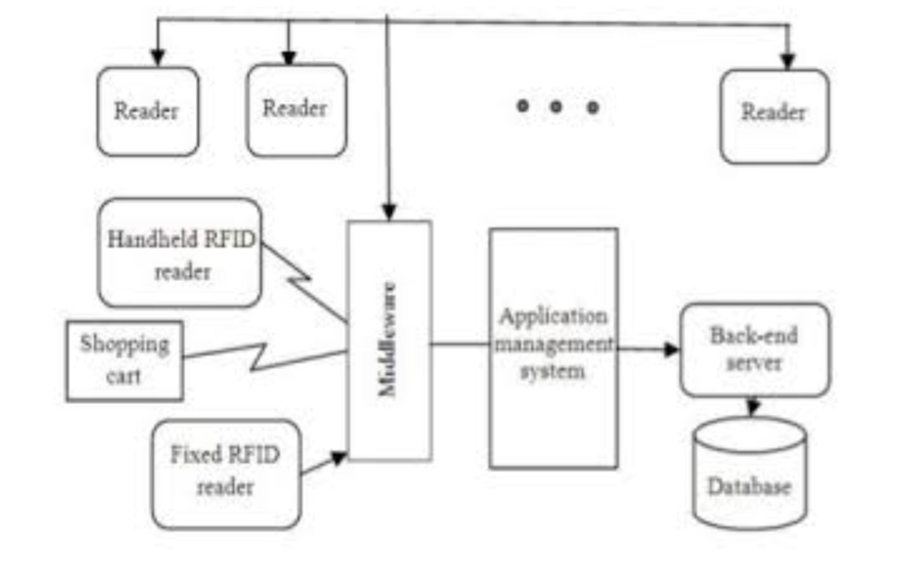

FLOWCHART

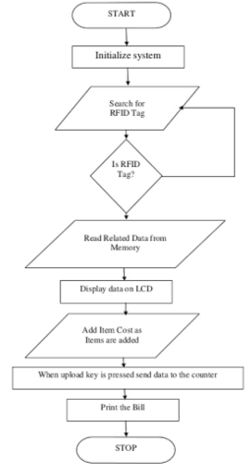

Key Milestones and Deliverables:
(Please list and describe the principal milestones and associated deliverables of the project. The timing of milestones is also to be shown in the Gantt chart in Annexure-A. Quarterly deliverables are preferred.)
S. No. | Elapsed time since start of the project | Milestone | Deliverable
1. | Week 01 – 04 | Planning, searching of project | Presentation, ideas overcome
2. | Week 05 – 08 | Submission of proposal | Report of functional and non-functional requirements
3. | Week 09 – 12 | Uses cases with narratives and ERD | Finalized
4. | Week 13 – 16 | Prototype development | Finalized
5. | Week 17 – 20 | Poster development and presentation
6. | Week 25 – 24 | Implementation and initial interface
7. | Week 25 – 28 | Database creation
8. | Week 29 – 32 | Integration of the system
9. | Week 37 – 36 | Testing of the project
10. | Week 37 – 40 | Final presentation
(Please add more rows if required.)
Gantt chart in Annexure-A 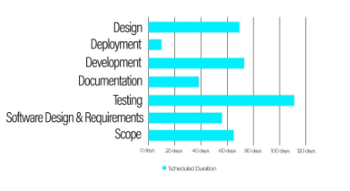
  - Risk Analysis

(Please list the risks that may cause delays in, or prevent implementation of, the project. For each risk estimate the likelihood, likely impact/consequences on the project and steps to minimize/avoid the risk.)

Risk | Likelihood  (Low, Med, High) | Impact | Mitigation
Financial risk | Med | No more features will be added. | Backup budget planning
Hardware failure | High | Data lost | Keep update backup files on  another external device.
Camera/scanner issue | High | Security issue. Products can be stolen | High alert buzz should be there if it’s not working.
Online shopping behavior | Low | Products can be short or lost | No return policy
App integration errors | Medium | No connection with the user to shop | Update systems on holidays

Section – 3

3.1 Resources & Other Requirements
Project Team:
The numbers in the table below must tally with the HR Cost sheet in the Budget file.
Title / Position | Number
Team Leads | 1
Researchers / Developers | 2
Researcher / Development Assistants | 4
Support Staff | 1
Contract Staff (please specify) | -
Others (please specify) | Deliver boy (4 or many)
Add more rows if required | -
Team Structure:
(Please define the team structure (organogram) and role/key responsibilities of each member. If in collaboration with another partner, the division of manpower at various locations of partners be provided.)
- Team Structure:
Project Manager
Dr. Mansoor Ibrahim

Team Lead
Mohammad Aashir Raza

Research
(Mahnoor, Essa)

Developer
Laiba Dar, Aashir

Title/Position  (of each member) | Role/Key Responsibilities | Minimum Qualification Required | Expertise / Background Required | Minimum Experience Required (years)
Front End Developer | Develop Front End, and Design UI | Bachelor | Using Java, XML | 2 Years
Algorithms researcher | Learn Python algorithms, and also know how to implement them, algorithms modification | Bachelor | Python and Java | 2 Years
Graphic Designer | To design the models of the software, prototypes, posters and other graphical datasets. | Bachelor | Adobe Illustrator, Photoshop, Aftereffects and XD | 3 Years
Backend Developer | Develop backend approach, API, Also knows about Database, Database modification. | Bachelor | Firebase | 2 years

Remarks:

1. Name & Signature of Supervisor:

2. Name & Signature of Co-Supervisor:

3. Name & Signatures of FYP Coordinator:

Annexure–B: Proposed Budget

Please use the embedded Excel Worksheet for providing budget details.

Double click the icon to open the worksheet.

Project Title
Proposed Budget
Summary:

(Do not enter the summary amounts (Sr.# 1-6) as they are automatically updated.) |  |  |  | Please read carefully before filling the sheets.
Sr. | Description | Amount (Rs) |  | Guidance Notes:  1. This worksheet has been developed for the convenience of the PI/PD and National ICT R&D Fund.  2. The filled in data and amounts are mere examples. Please enter the actual data and amounts relevant to your project.  3. Total amounts mentioned in the Summary (Sr. # 1-6) are updated automatically from the detailed worksheets.  4. Rows and Columns may be added where required.  5. Services such as rent, phone, utilities, internet may be included in Institutional/ Organizational Overheads and should not be charged separately.  6. Please do not change the formula and layouts.  7. Proper justifications, purposes / remarks MUST be provided against each item.
 | Heads of Expenditure
1 | Technical HR Deployment Cost | Rs.120,000
2 | Equipment’s | Rs.71,000
3 | Traveling | Rs.10,000
4 | Boarding & Lodging | Rs.43,000
5 | Miscellaneous | Rs.17,000
 | Sub Total: | Rs.261,000
6 | Contingency | Rs.50,000
7 | Institutional/Organizational Overheads | Rs.130,000
 | Total Budget: | Rs.441,000
Funding Sources: (Please indicate funding sources for the project)
Sr. | Funding Source | Amount (Rs) | % of Total Funding
1 | National ICT R&D Fund | Rs.441,000 | 100%
2 | Internal Funds |  | 0%
3 | Other Sources (specify) |  | 0%
4 | (Add more entries, if required)
 | Total: | Rs.441,000 | 100%

Annexure–C: Business Canvas Model
Problem  With all its good features, has some weakness. Goods delivered may be damaged and no refund policy is available to the customer. Security is a major issue in a crowded environment as customer belongings, credit and debit card information are sometimes stolen. Errors are usually inevitable when in putting product into the electronic Point of Sales when demand is high (crowded) which often lead to loss of sales for the supermarket when using current systems. | Solution  Barcodes eliminate the possibility of human error. The occurrence of errors for manually entered data is significantly higher than that of barcodes. A barcode scan is fast and reliable, and takes infinitely less time than entering data by hand. Using a barcode system reduces employee training time.  Barcodes provide better data. Since one barcode can be used for inventory and pricing information, it is possible to quickly obtain data on both. Furthermore, barcodes can be customized to contain other relevant information as needed. They provide fast, reliable data for a wide variety of applications.  Data obtained through barcodes is available rapidly. Since the information is scanned directly into the central computer, it is ready almost instantaneously. This quick turnaround ensures that time will not be wasted on data entry or retrieval.This shopping system is more secure, private and easy to use than any other system | Unique Value Proposition  BGSCS, would reduce congestion by implementing a collection point where goods ordered online can be collected by customers, the use of credit and debit cards would be substituted with the use of vouchers and cash payments, mistakes made by the cashier will be minimized with the use of the barcodes generated when an order is made by the customer online. The cost of purchasing more electronic Point of Sales systems would be reduced as the use of the BGSCS which is cheap and requires little maintenance by the administrator will consequently increase profit.  The main scope of our project is to deal with the daily problem people face while shopping. The desktop will be made on C# and the technology which we will be using is mobile application and language will be kotlin. |  | Unfair Advantage  In our project probably, no one can easily copy it because we have used certain kotlin techniques and have created custom algorithms for this to execute. These days smart shopping system are rare in Pakistan using RFID tags and barcodes. | Customer Segments  The software is made for shopping system so all those customers who shop from our organization in which we have installed RFID tag products can shop from there. Those who are using our application can only shop.  New customers who have initially starting using it can be a part of our system we have special discounts for our fresh/newly customers. They will be having specific ids where their all the data will be gathered.
 | Key Metrics  In order to design and implement this system the following objectives must be attained:  Review existing systems and identify their various limitations Design a barcode generating shopping cart that that is simple and scalable as new services can be easily implemented and added to the system. Design an administrator system web application which would be installed on the Point of Sales machines that would manage orders and payments of the customer.  Design and implement a robust database that would eliminate redundancy, improve data integrity, and enhance concurrent operations. It would also access control measures, this would enhance the security of the application and the database. |  |  | Channels  Channels for reaching to customers are:  Playstore apps  Facebook  Instagram  Tv advertisement  Newspaper
Cost Structure  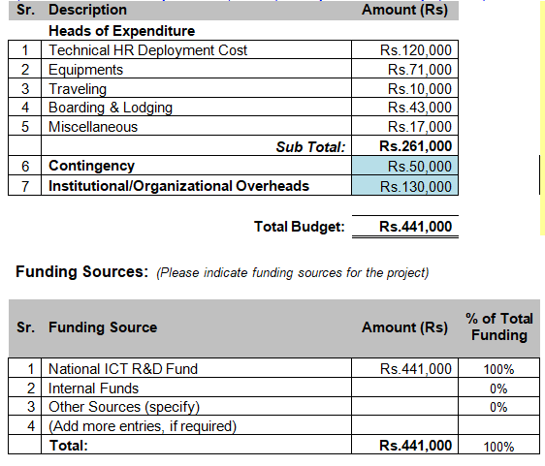 |  |  | Revenue Streams  We will take our revenue form periodic method  We will provide our system to a mart or store .They will provide us all the money to make the system for their organization/store . So in this way they will provide and generate our revenue every month according to the need of customers.

Bibliography

https://www.researchgate.net/publication/318946385_RFID_based_Advanced_Shopping_Trolley_for_Super_Market

https://www.slideshare.net/mobile/MahanteshHiremath11/smart-shopping-system-77464373

Technical HR Deployment:

Time Allocation for PI/CPI | Principle investigator (PI)  20% | Co-Principal Investigator (CPI)  40% | Researcher | Developers | Database Designer | UI  Designer | TOTAL
40 weeks
Numbers | 1 |  | 1 | 2 | 1 | 1 | 7
Months | 1 |  | 2 | 6 | 2 | 2
Monthly Fee | Rs.10,000 |  | Rs. 5,000 | Rs. 5,000 | Rs. 10,000 | Rs. 10,000
Total: (num*months*monthly fee*time) | Rs.10,000 | Rs.0 | Rs.10,000 | Rs. 60,000 | Rs. 20,000 | Rs. 20,000 | Rs. 120,000

Total (Technical HR Deployment): Rs. 120,000

Total (HR Cost): Rs. 120,000

Equipment’s Costs:

Description | No. | Unit cost | Amount (Rs) | Specifications | Justification

Major Equipment
Voyager 1250g  Honeywell Barcode Scanner | 1 or 2 | Rs.15,000 | Rs. 30,000 | Honeywell features a lightweight, ergonomic design that is drop-resistant up to 4.9 feet.  Scanner Type: Single line  Dimensions: 6.6 x 2.9 x 2.3" (168 x 74 x 60 mm)  Weight: 4.7 oz (133 g) | Development  purpose
(LF) Low frequency RFID Tag | 2 | Rs. 8,000 | Rs. 16,000 | covers from 125KHz to 134KHz and provides a read range | Development  purpose
Database Server (ODBC version 4.0) | 1 | Rs. 25,000 | Rs. 25,000 | Private drivers  Additional capability reporting  Language extensions through additional SQL Escape Clauses  Semi-structured data – Tables whose schema may not be defined or may change on a row-by-row basis  Hierarchical Data – Data with nested structure (structured fields, lists)  Web Authentication model | Development purpose

Sub Total: Rs. 71,000

Total Equipment Cost Rs. 71,000

Traveling:

Mode of Travel | No. of Trips | No. of Persons | Per Trip/Per Person Cost | Total Amount (Rs.) | Itinerary (from-to) Purpose / Justification | Purpose / Justification

40 weeks
Land Travel
By road | 20 | 2 | Rs. 200 | Rs. 8,000 | In Karachi | Petrol Expenses

Sub Total: Rs. 10,000
Total (Year 1):

Total (Traveling): Rs.10,000

Boarding & Lodging:

Description | No. of Trips | No. of people/Trip | No. of days/Trip | Meeting hours | Amount  (Rs.) | Justification

Year 1
Room rent |  |  |  |  | 12,000 | lumpsum cost
Food Allowance |  |  |  |  | 17,000 | lumpsum cost
Meeting | 5 | 2 | 3 | 2 hrs | 14,000 | lumpsum cost
Total (year 1): Rs. 43,000

Total (Boarding & Lodging): Rs. 43,000
Miscellaneous:

Description | No | Per unit cost | Amount (Rs.) | Remarks/Justification

Research Materials & Supplies

Software tools/License | 1 | Rs.10,000 | Rs. 10,000 | (Hosting and Deployment)

Sub Total: Rs. 10,000

Other
Other 1 | 1 | Lumpsum | Rs. 7,000
Other 2
Add more entries if required
Sub Total: Rs.7,000

Total (Miscellaneous): Rs.17,000

ENTITY RELATIONSHIP DIAGRAM

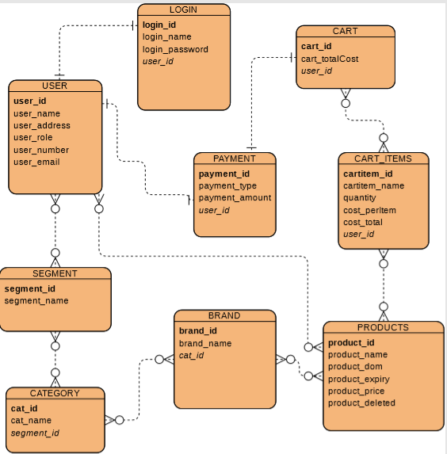

USE CASE

  - To manage an application

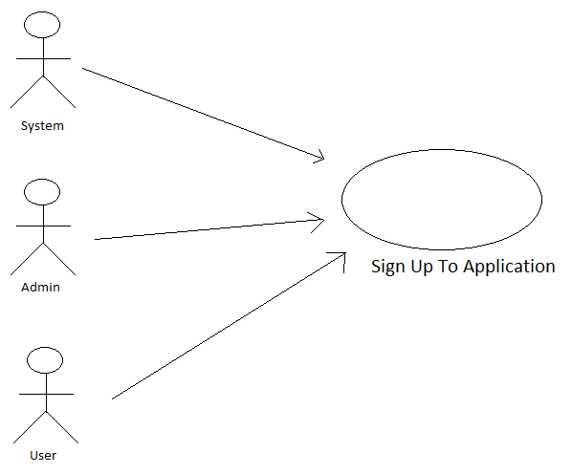

Use Case Name: | Sign up to application
ID: | UC-STA-01
Actors Involved: | System, Admin ,User
Brief Description | Actor enters the name, cell no, address, email and password to sign up to the system.
Pre-Conditions
Post-Conditions
Normal Flow of Events: | Actor Action | System Response
Normal Flow of Events: | - Enter name, cell no, address, email and password to login  - Clicks the sign up button. | - System displays the actor mail page on successful sign up.  - System displays error message on invalid sign up.

  - Maintain application
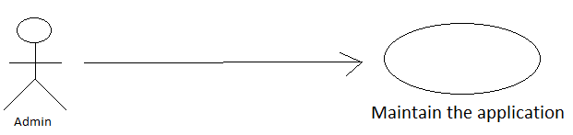

Use Case Name: | Maintain the application
ID: | UC-MTA-002
Actors Involved: | Admin
Brief Description | Admin maintain all the application such as add, delete and edit all inventory items and also add and delete the users.
Pre-Conditions | Use Case ID: UC-STA-01
Post-Conditions | User can easily access the application
Normal Flow of Events: | Actor Action | System Response
Normal Flow of Events: | - Admin maintain all application.  - Add and delete Users.  - Add, delete and edit all inventory items.  - Control of all application. | - Unique users and inventory items ID is created in the Database.  - The Items and users in the database.  - The user and inventory items saved in the data base with the Status as NEW and UPDATED.

1.3 User login Application
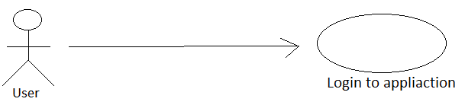
Use Case Name: | User login to application
ID: | UC-ULA-00
Actors Involved: | User
Brief Description | User can login to application to add, delete, add the number of quantities of an item and also edit the items
Pre-Conditions | Use Case ID: UC-STA-01
Post-Conditions | User can easily scan items and add or delete from their list
Normal Flow of Events: | Actor Action | System Response
Normal Flow of Events: | 1. User can login to application.  2. User can add, delete and edit all inventory items.  3. User can generate the list of an items by click on the generate list button. | 1. System show the massage either user is valid or not if valid system save user information into Database.  2. System also save the list of inventory item and delete items from the list according to user’s actions.  3. System also generate a list of items and also generate the general leaguer for accountability.

